**HTML Styles**

**Add Styles in HTML Element:**

The HTML style attribute is used to add styles to an HTML element, such as color, font, size, and more.

**Example:**

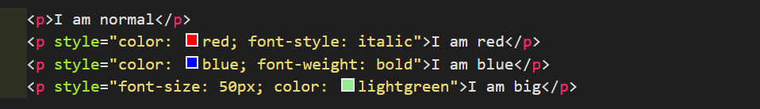

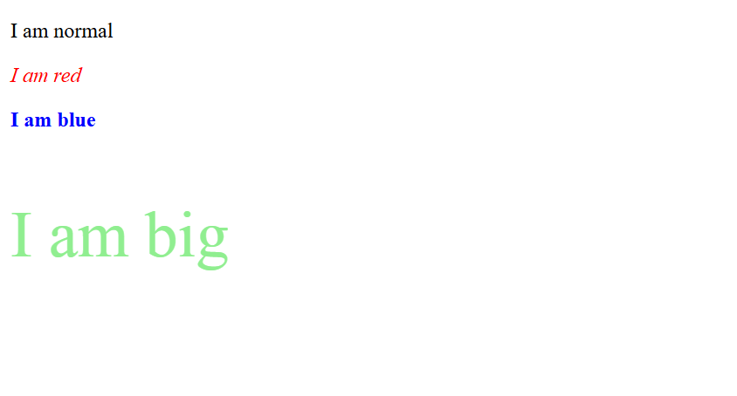

**The HTML Styles Attribute:**

The HTML style attribute defines style for an HTML Element or add CSS in HTML document.

Setting the style of an HTML element, can be done with the style attribute.

**Syntax:**



Here, the property is a “CSS property”. The value is a “CSS value”.

**Most Used Properties of Styles Attribute:**

In this chapter we will learn the most used and important styles for an HTML Element:

1. Background-Color
2. Color
3. Font-Family
4. Font-Size
5. Text-align

**Background-Color Property:**

The CSS background-color property defines the background color for an HTML element.

**Example:**

Set the background color for a page to powderblue:

**Code:**

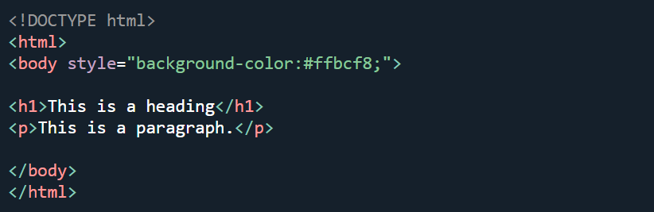

**Output:**

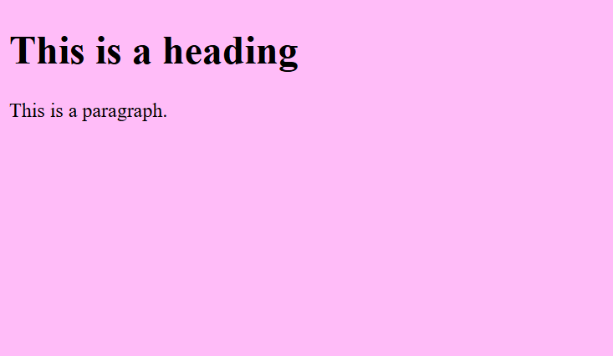

**Example:**

Set background color for two different elements:

**Code:**



**Output:**

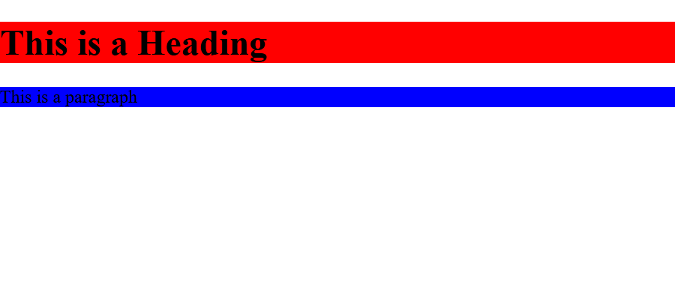

**Color Property:**

The CSS color property defines the text color for an HTML element:

**Code:**



**Output:**



**Font-Family Property:**

The CSS font-family property defines the font to be used for an HTML element:

**Code:**



**Output:**

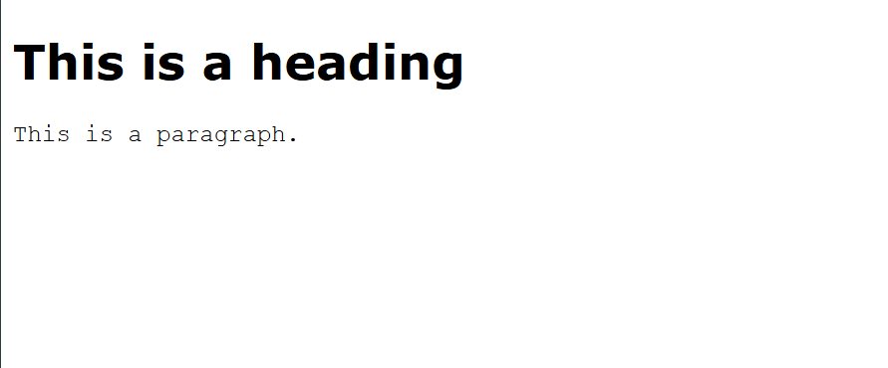

**Font-Size Property:**

The CSS font-size property defines the text size for an HTML element:

**Code:**



**Output:**

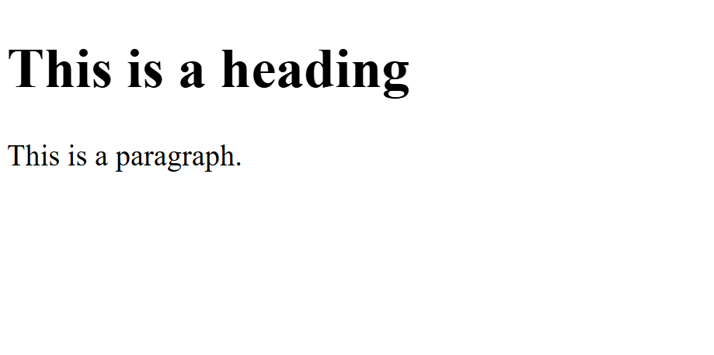

**Text Align Property:**

The CSS text-align property defines the horizontal text alignment for an HTML element:

**Code:**



**Output:**

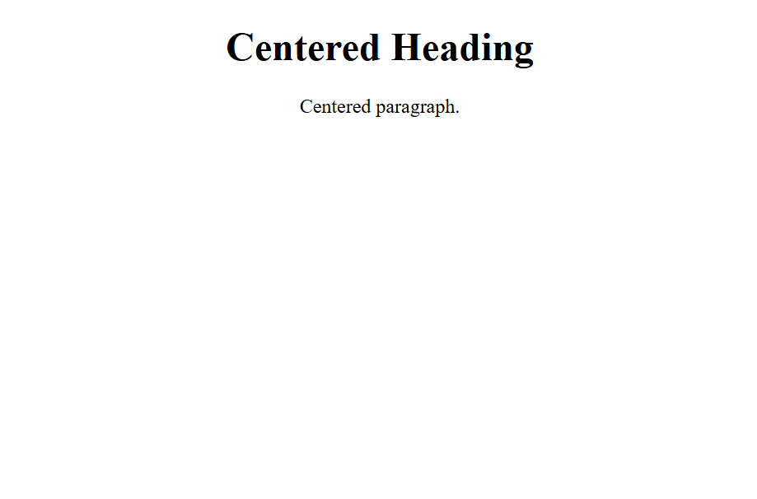

**Summary:**

* Use the style attribute for styling HTML elements
* Use background-color for background color
* Use color for text colors
* Use font-family for text fonts
* Use font-size for text sizes
* Use text-align for text alignment